# 

# 

# 

# Team Tetrahedron

Milestone #4 -

Data Analysis



Team members:

Lauro Fialho Müller

Chandan Radhakrishna

Raghava Vinaykanth Mushunuri

Kavya Vajja

Arnab Das

Anjan Chatterjee

26.05.2020

# Table of contents

Overview 2

Input variables measured 2

Output variables measured 2

Erich-Weinert-Str 3

Experimental observations and final conclusions 4

Am Fuchsberg 5

Experimental observations and final conclusions 6

Leipziger Str. South 7

Experimental observations and final conclusions 8

Leipziger Str. North 9

Experimental observations and final conclusions 10

Traffic lights 11

Bicycles, pedestrians and trams 12

For Trams 13

Car Moving Direction with Count & Probability 13

Additional measurements 16

Inputs: 16

Outputs: 16

Difficulties encountered while obtaining the data 17

Dealing with trade-off between good estimation of distribution function and variance 17

Limitations on the accuracy or validity of the data 20

Cost overview 21

Future work 22

# Overview

The data analysis in conducted this milestone. The main motivation here is to identify the theoretical distributions that best fit the data so that we can use them when building our simulation model. Other elements such as pedestrian and traffic light modelling are also considered.

# Input variables measured

1. Inter arrival times are measured as inputs for estimating the distribution functions.
2. Total bicycles and pedestrians entering the system per hour.

# Output variables measured

1. Frequency of observed values for k number of bins
2. Expected frequency for each distribution type for k number of bins
3. Inverse values of cumulative distribution function is measured for each distribution type considered.
4. Underlying distribution functions for the vehicles entering each lane of the intersection point.
5. Statistics of each distribution is obtained
6. Chi square values for each distribution type taken at every possible k value

(that is in the range of k = to n/5, n is total number of samples)

1. Probabilities for the vehicle to take a turn is measured.

# Erich-Weinert-Str

**Histogram:**

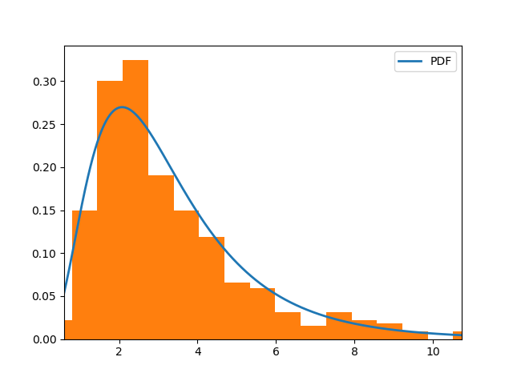 **QQ plot:**

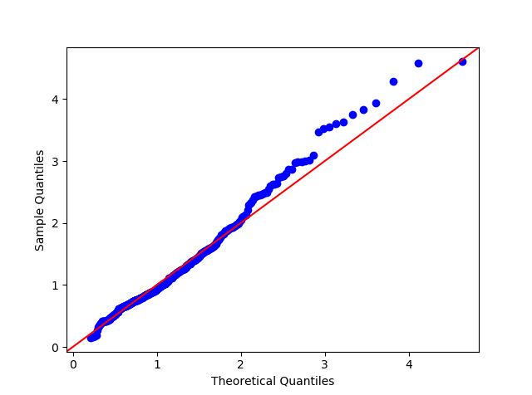

## Experimental observations and final conclusions

**Observations:**

* Distribution type: Lognormal
* Statistics:
  + Mean = 1.161
  + Standard deviation = 0.533
  + For k = 31, chi-square calculated less than critical

From the above comparisons we can conclude the test failed to reject the null hypothesis and the observed values and Expected values have correlation and the expected values are not occurring just by a mere coincidence.

The expected data is following the observed data with 95% confidence level.

**Conclusion :**

**Lognormal** with mean = 1.161, standard deviation = 0.533

# 

# Am Fuchsberg

**Histogram:**

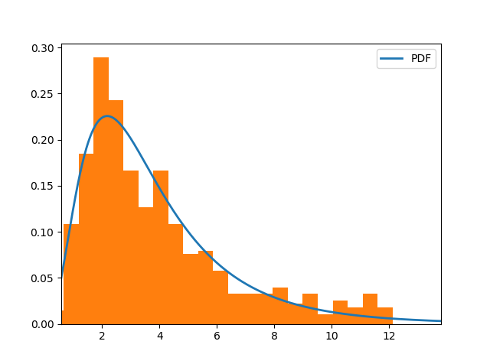

**QQ plot:**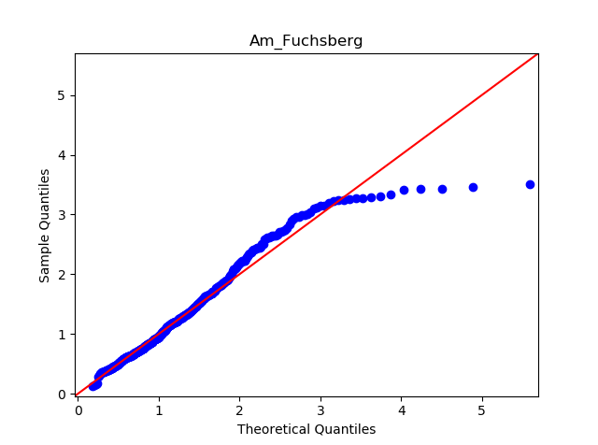

## Experimental observations and final conclusions

**Observations:**

* Distribution type: Lognormal
* Statistics:
  + Mean = 1.267
  + Standard deviation = 0.593
  + For k = 27, chi-square calculated less than critical

From the above comparisons we can conclude the test failed to reject the null hypothesis and the observed values and Expected values have correlation and the expected values are not occurring just by a mere coincidence.

The expected data is following the observed data with 95% confidence level.

**Conclusion :**

**Lognormal** with mean =1.267, standard deviation = 0.593

# Leipziger Str. South

**Histogram:**

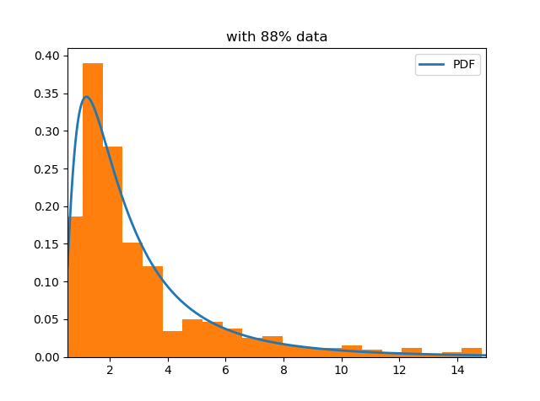

**QQ plot:**

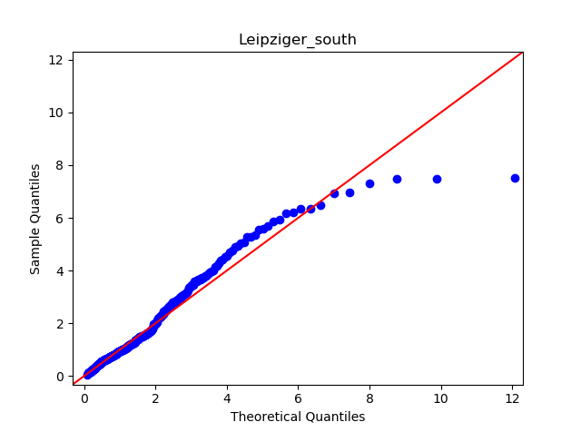

## Experimental observations and final conclusions

**Observations:**

* Distribution type: Lognormal
* Statistics:
  + Mean = 0.662
  + Standard deviation = 0.871
  + For k = 34, chi-square calculated less than critical

From the above comparisons we can conclude the test failed to reject the null hypothesis and the observed values and Expected values have correlation and the expected values are not occurring just by a mere coincidence.

The expected data is following the observed data with 95% confidence level.

**Conclusion:**

**Lognormal** with mean = 0.662, standard deviation = 0.871

# Leipziger Str. North

**Histogram:**

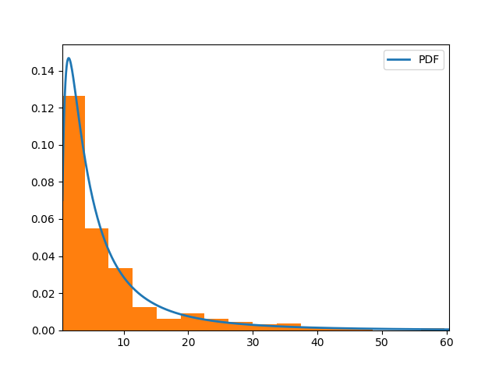

QQ plot:

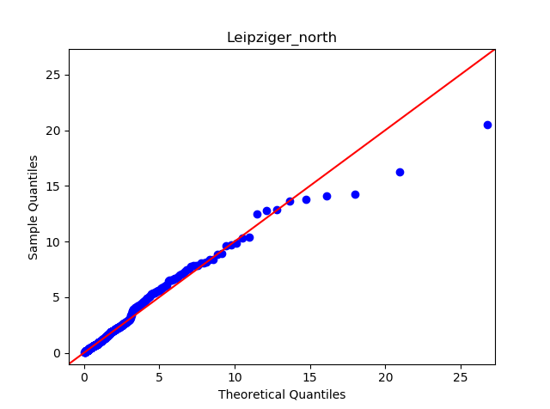

## Experimental observations and final conclusions

**Observations:**

* Distribution type: Lognormal
* Statistics:
* Mean = 1.511
* Standard deviation = 1.112
* For k = 25, chi-square calculated less than critical

From the above comparisons we can conclude the test failed to reject the null hypothesis and the observed values and Expected values have correlation and the expected values are not occurring just by a mere coincidence.

The expected data is following the observed data with 95% confidence level.

**Conclusion:**

**Lognormal** with mean = 1.511, standard deviation = 1.112

# Traffic lights

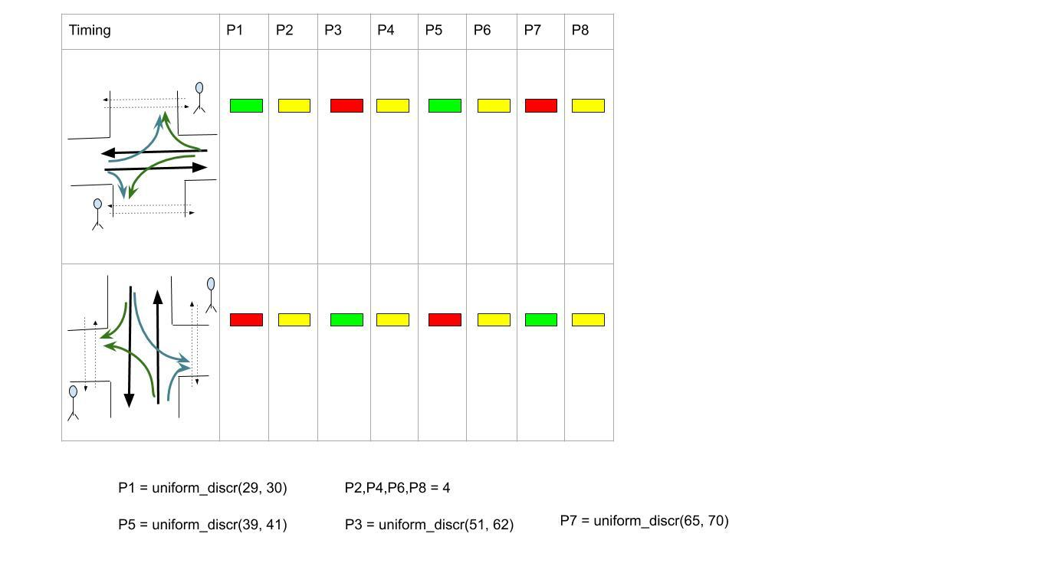

# Bicycles, pedestrians and trams

**For Erich-Weinert-Str to Am Fuchsberg**:

* **Distribution type: Uniform-discrete [9 sec,34 sec]**
* Minimum value = 386/hour (9 sec)
* Maximum value = 106/hour (34 sec)

**For Am Fuchsberg to Erich-Weinert-Str**:

* **Distribution type: Uniform-discrete [10sec, 20sec]**
* Minimum value = 393/hour (3600/393 = 10/sec)
* Maximum value = 186/hour (3600/186 = 20/sec)

**For Leipziger-str south to Leipziger-str North**:

* **Distribution type: Uniform-discrete [10sec, 27sec]**
* Minimum value = 363/hour (10sec )
* Maximum value = 137/hour (27sec)

**For Leipziger-str North to Leipziger-str south**:

* **Distribution type: Uniform-discrete [12 sec, 28 sec]**
* Minimum value = 290/hour (12 sec)
* Maximum value = 129/hour (28 sec)

## For Trams

* **Distribution: Truncated normal**
* Min value = 8 minutes, Max value = 12 minutes,
* Standard deviation = 2 minute, mean = 10minutes

# Car Moving Direction with Count & Probability

Data Provided by Landeshauptstadt MAGDEBURG

Year : 2015

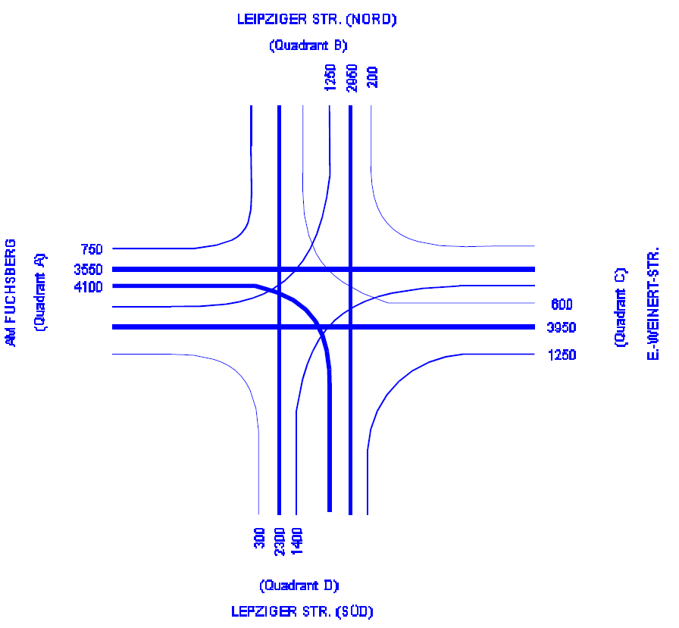

**Am Fuchsberg** to Leipziger strasse South 300

Leipziger strasse North 1250

Straight to Erich-Weinert-Str 3950

Total 5510

P1 = 300/5500 = 0.05

P2 = 1250/5510 = 0.23

P3 = 3950/5510 = 0.72

**Erich-Weinert-Str** to Leipziger strasse North 200

Leipziger strasse South 1400

Straight to Am Fuchsberg 3550

Total 5150

P4 = 200/5150 = 0.04

P5 = 1400/5150 = 0.27

P6 = 3550/5150 = 0.69

**Leipziger Str. South** to Am Fuchsberg 4100

To Erich-Weinert-Str 1250

Straight to Leipziger Str. North 2950

Total 8300

P7 = 4100/8300 = 0.49

P8 = 1250/8300 = 0.15

P9 = 2950/8300 = 0.36

**Leipziger Str. North** to Am Fuchsberg 750

To Erich-Weinert-Str 600

Straight to Leipziger Str. South 2300

Total 3650

P10 = 750/3650 = 0.21

P11 = 600/3650 = 0.16

P12 = 2300/3650 = 0.63

# Additional measurements

## Inputs:

1. Tram times
2. Pedestrian traffic lights

## Outputs:

1. Sum of squared errors to check how well the expected value fits with the actual value curve.

# Difficulties encountered while obtaining the data

We were unable to collect the data.

While analyzing the data we have encountered the problem of outliers due to which proper estimation of the distribution function is not done as the distribution function tries to fit the entire data which really does not have any impact on the system. The expected values are not in any way related to the actual data points thus leading to a false estimate of distribution function.

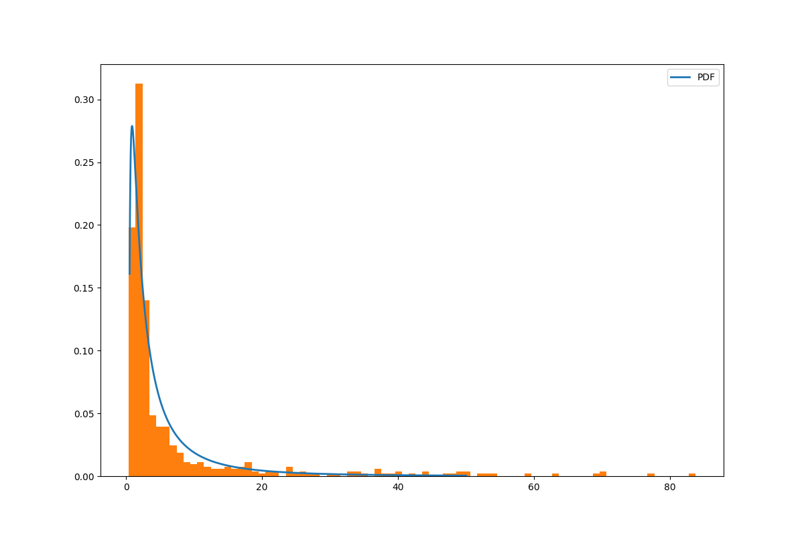

# Dealing with trade-off between good estimation of distribution function and variance

Data censoring is done in order to reduce the variance and the mean is shifted to a point where the amount of data is high so that we can estimate a good fit for the data.

Following are the observations:

**Leipziger str south:**

**Before removing:**

* Variance: 145.705501
* Expon SSE: 22771.40234860699, rejected null hypothesis with 95% C.I
* Log norm SSE: 10547.130880170222, rejected null hypothesis with 95% C.I
* Norm SSE: 43318.018614922636, rejected null hypothesis with 95% C.I

## Data < 15

**exp:** close fit in q-q plot but Rejected null hypothesis with 95% confidence interval as chi value is not less than tabulated (close to theoretical ), sse = 96.99359997385118

**Lognormal:** Failed to reject null hypothesis with 95% confidence interval at k = 34 chi =40.55014279825781 < 44.985 (df = 31) (not only 34but for most of them), sse= 294.0773265479426

**Norm**: Rejected null hypothesis with 95% confidence interval, chi value is not less than tabulated, sse =959.3228009715183

**Variance:** 7.719009

## Data < 25

**exp:** Rejected null hypothesis with 95% confidence interval but close fit in qq plot, sse = 908.1043538692305

**Lognormal:** failed to reject null hypothesis at k = 80, chi = 96.8853491051358< 98.484 (df = 77)and for few other values after 81, close fit in qq plot, sse = 1139.8242136414551

**Norm:** No proper fit and Rejected null hypothesis with 95% confidence interval, sse = 3620.8693617585723

**Variance:** 19.972214

## Data < 30

**exp:** close fit but Rejected null hypothesis with 95% confidence interval , chi value is not less than tabulated for any k , sse = 1506.8272257584504

**Lognormal:** failed to reject null hypothesis with 95% confidence level at k=83 , chi = 97.01192955789713< 101.88(df = 80), sse =1458.0231606620443

**Norm:** Rejected null hypothesis with 95% confidence interval, chi value is not less than tabulated for any k , sse = 5141.926255269538

**Variance:** 26.079071

## Data < 40

**exp:** Rejected null hypothesis with 95% confidence interval, chi value is not less than tabulated for any k , sse = 4586.7407320703205

**Lognormal:** failed to reject null hypothesis at(k=91) = chi = 108.835 < 110.90(df = 88), sse = 3141.7580461553866

**Norm:** Rejected null hypothesis with 95% confidence interval, chi value is not less than tabulated for any k , sse = 11457.69245570545

**Variance:** 48.390222

## CONCLUSION:

lognormal Data<15 would be a best choice as it failed to reject null hypothesis and q-q plot fits well with slope =1 for considerable range.



As the variance decreased to a greater extent the mean is shifted and does not consider the data which has very less impact on the system.

# Limitations on the accuracy or validity of the data

1. The data is cleaned for the sole purpose of getting an optimum distribution function neglecting the data which does not really impact the system.
2. The data is biased towards smaller interarrival times.
3. Patterns in the data are likely to change over time and timely analysis has to be done.
4. Pedestrian data is not precise enough to do the analysis so we have to go with uniform distribution.

# Cost overview

The chart below presents a two-dimensional breakdown of costs, aggregated by both milestone and individual members.

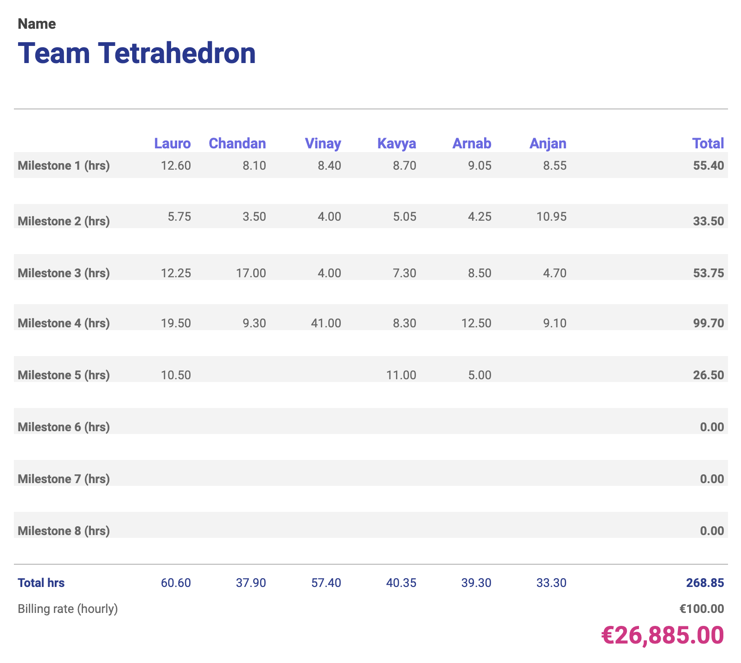

Additionally, the chart below shows the cumulative cost of the project so far. The orange bars represent the planned milestone costs, and the blue line the planned cumulative cost. The green bars represent the actual milestone costs, and the red line the actual cumulative cost.

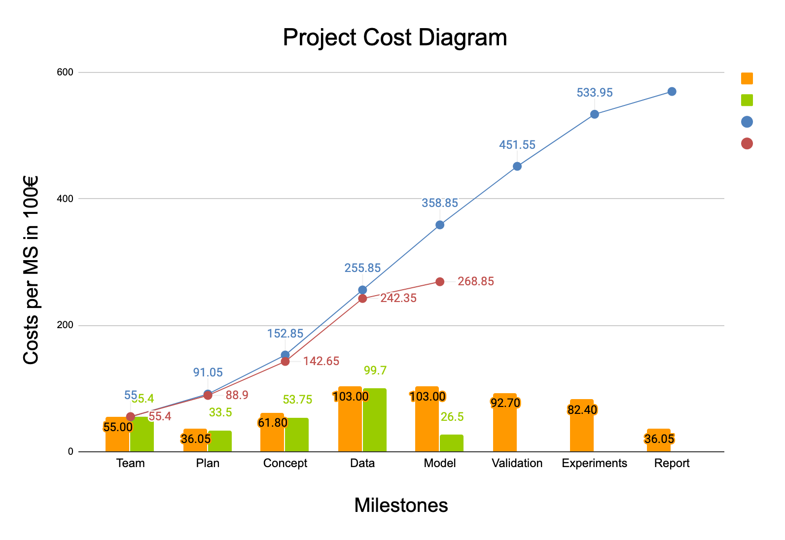

# Future work

Complete the simulation model and validate the model.